**Task Set 1:**

1.1A: Screenshot of packets being captured successfully

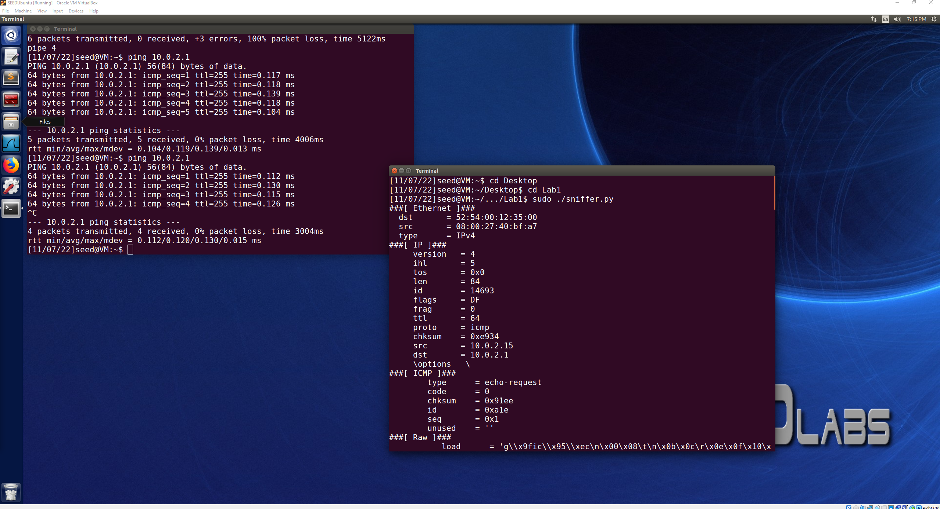

When running the program without the root privilege, the program attempts to run, but then ultimately returns a permission error that is labeled as [Errno 1] Operation not permitted. This simply just means that the action that the program was trying to run, which would be the packet sniffing using scapy was not performed with the right level of permission. This means that the program needs to be run with root privileges.

1.1B:

Capture only the ICMP packet change:

pkt = sniff(filter='icmp',prn=print_pkt)

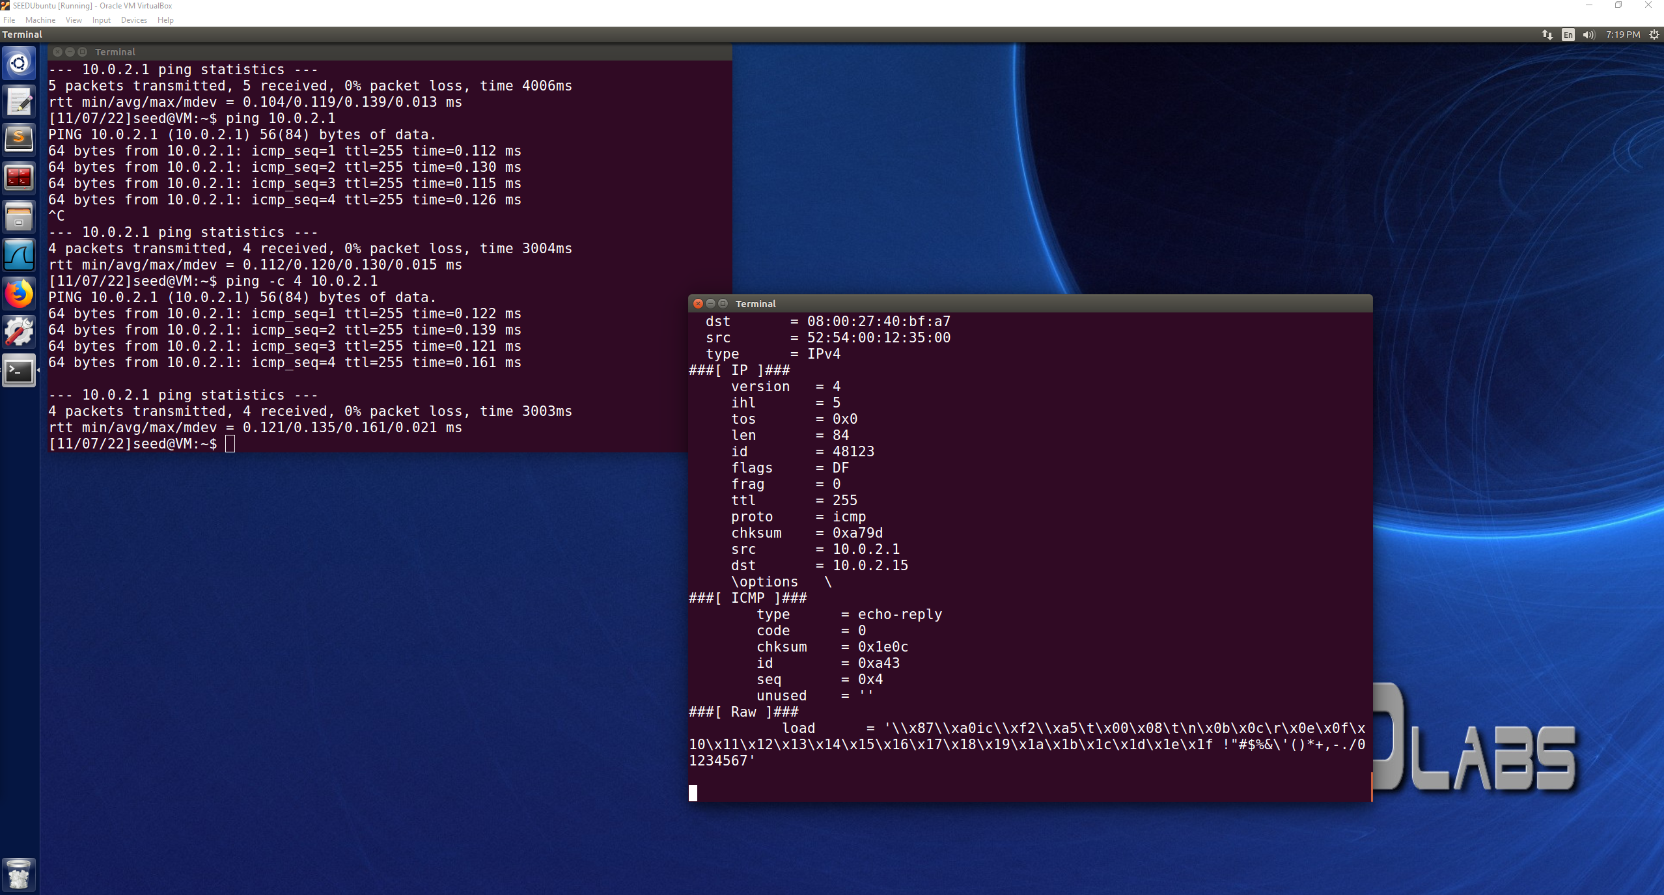

Capture any TCP packet that comes from a particular IP and with a destination port number 23:

pkt = sniff(filter='tcp and dst port 23 and src host 10.0.2.15',prn=print_pkt)

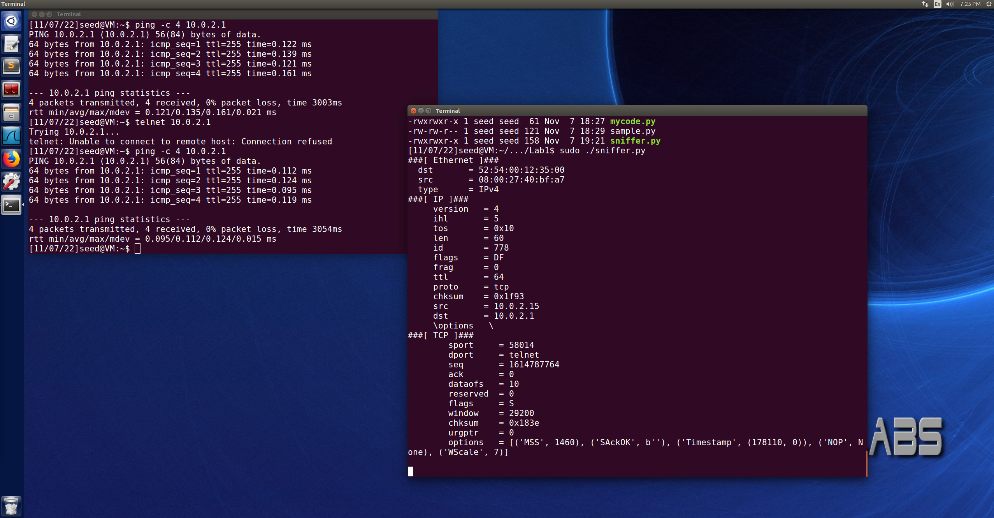

Capture packets come from or to go to a particular subnet. You can pick any subnet, such as 128.230.0.0/16; you should not pick the subnet that your VM is attached to:

pkt = sniff(filter='dst net 128.230.0.0/16',prn=print_pkt)

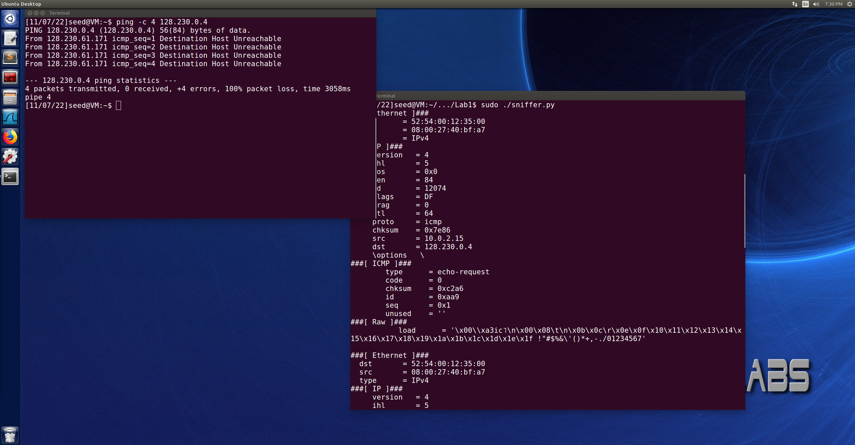

**1.2**

Original: 10.0.2.15

Spoofed example: 10.0.2.10

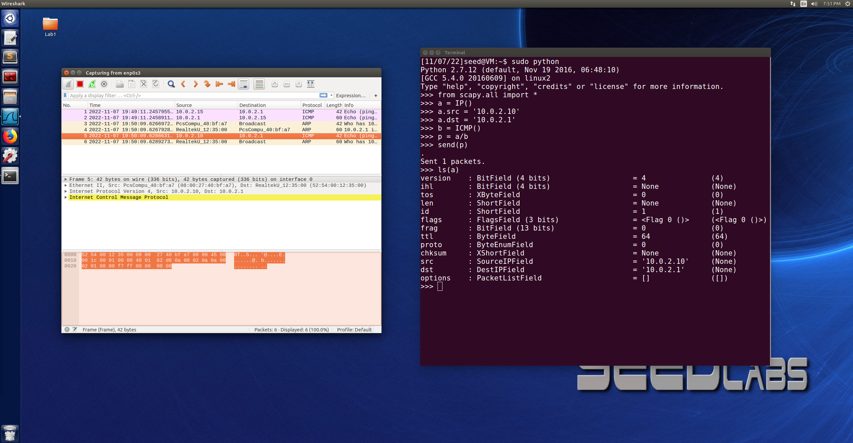

**Task 1.3:**

Destination: 142.250.191.132

TTL = 1 – 10.0.2.1

TTL = 2 - 192.169.1.1

TTL = 3 – 142.250.191.132

Echo response received

**Task 1.4:**

VM #1 : Running the program IP: 10.0.2.15

VM #2: IP: 10.0.2.4 (shut off)

VM #3: IP: 10.0.2.5 (trying to ping VM #2, looking for response from VM #1 spoofing as VM #2 responding)

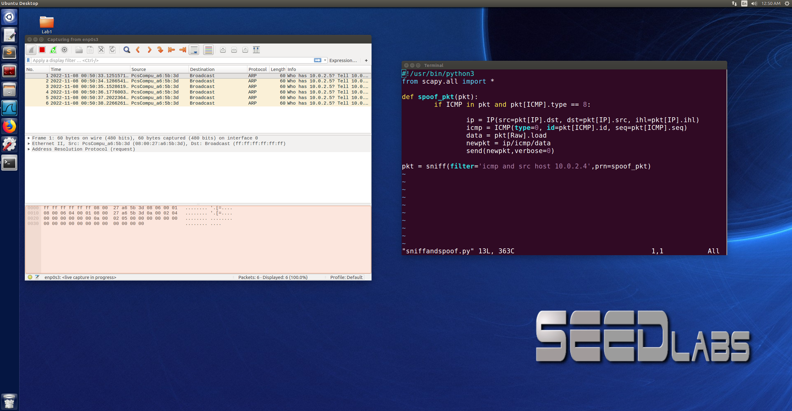

I am not entirely sure where I went wrong with trying to sniff and then spoof the IP to respond, I could not find where I was going wrong this problem, and this is the program that I was attempting to use. The pings were being broadcasted and I am disappointed in myself that I cannot figure out where I went wrong on this task.

**Task 2: IP fragmentation and ICMP redirect**

1.a: Each fragment contains 32 bytes of data, total length is 96 bytes

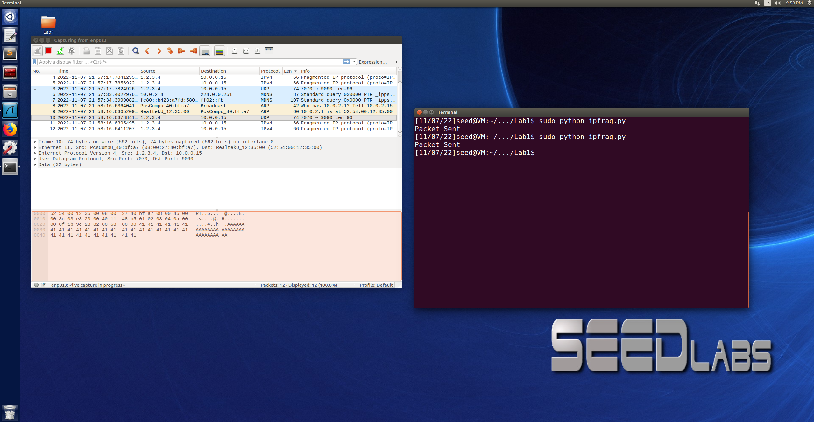

1.b:

**First scenario:**

1440 bytes of data in 3 total fragments

Original off-set of the second fragment is 60, new value for the second fragment off-set to cause overlap will be 50. This will cause 80 bytes of data to overlap between fragments 1 and 2.

In WireShark, it still shows the 3 packets coming through containing 480 bytes per packet and a length of 1440 as shown below. However, this packet would now have 80 bytes between fragment 1 and 2 that are overlapped during the re-assembly of the packet so the information that would be in an overlapped fragment would be messed up during the reassembly.

If the second packet were sent over the first packet, the bytes would still be overlapped. However, whichever fragment was sent and received first would have the overlapping 80 bytes overwritten by that next fragment due to the off set being incorrectly placed.

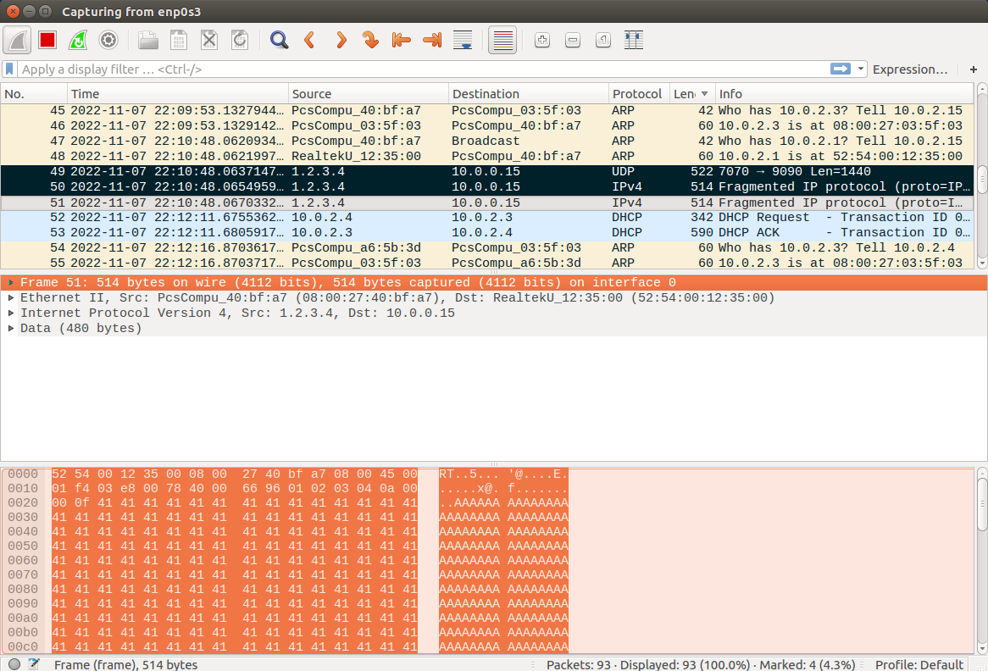

**Second scenario:**

980 bytes of data in 2 total fragments

First fragment is 576, second fragment is 404 bytes with an off set of 72 for correct fragmentation re-assembly. The off-set for the second fragment will be 1 now to cause the second fragment to be completely enclosed in the first fragment.

When the fragments were sent as the first fragment being sent first and the second smaller fragment sent second, both of the fragments can be observed as being sent through WireShark with the correct length and datagram sizes on them. There was no error when being sent. However, when the first fragment arrives it will be set and then the second fragment arrives and with an off-set of 1, the 404 bytes of the second fragment will have an overlap of 404 causing 404 bytes of the first fragment to be overwritten.

When sending the second fragment first, and the first fragment second. The second fragment is received first and the first fragment received second. The same situation as described above will occur with the overlap, but the fragments both have the same ID and the first fragment has a flag of 1 and the second fragment has a flag of 0, so they will still be assembled with each other, but the overlapping will still occur overwriting data that is then lost due to the off-set being incorrect.

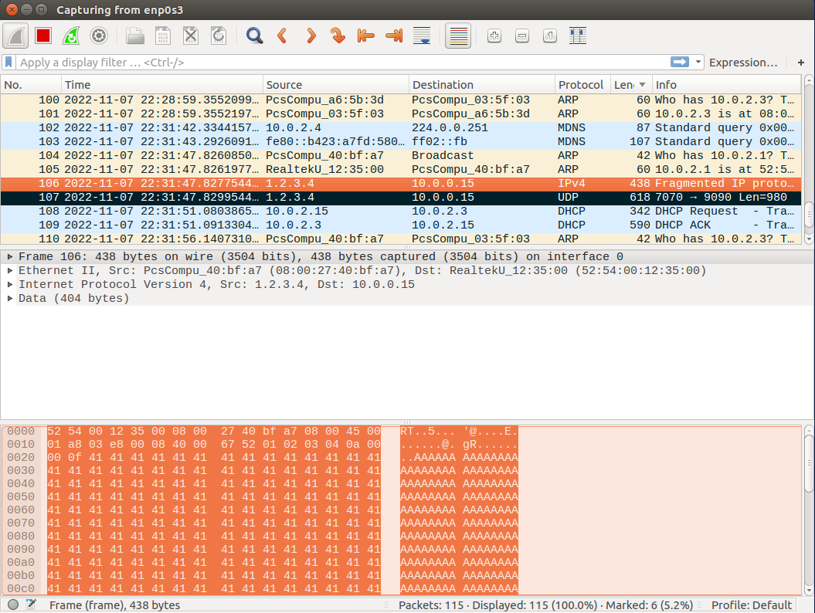

**Task 1.c:**

2^16 is 65536, so if we create a packet that was 66000 bytes it would exceed the maximal size of an IP packet. This can be fragmented down to become possible. If we assumed an MTU of 1500 which is typical, there would be 44 fragments that needed to be sent. When attempting to send this package, each fragment would contain a payload of 1480 other than the first fragment and the 44th fragment which would contain 860 bytes. This would allow a packet of size 66000 bytes to be sent and then reassembled.

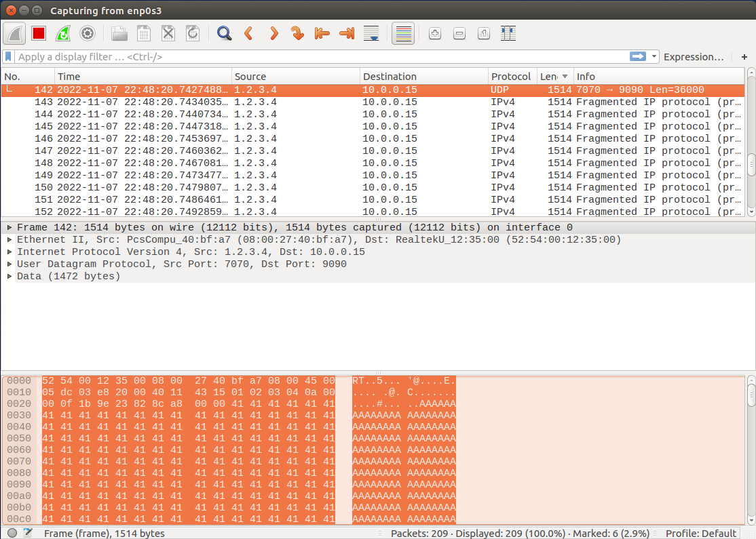

**Task 1.d:**

When the packets were sent as a fragment, they could not be fully reassembled due to the next part of the fragment never showing up and the fragment staying in the kernel memory until they time out. When sending the packeted fragments, it is incredibly easy to send a lot of packets very fast causing the memory of the victim system to fill up before the IP packets time out. This results in a Dos (denial of service) attack. Observing on Wireshark from the attacking vm, all of the fragments were seen going out to the intended victim, and on the victim vm on Wireshark all of the fragments were being received but was not displaying that the fragment reassembly time was exceeded, so the fragments were able to keep being received at the same rate but not timing out at the same rate. If the victim system did not have a packet filter security in place, this would result in a DoS attack causing the system to shut down.

**Task 2: ICMP Redirect Attack**

VM(Host A) Victim 10.0.2.4

VM(Host B) Attacker 10.0.2.15

Destination B(outside webserver): 172.217.2.36

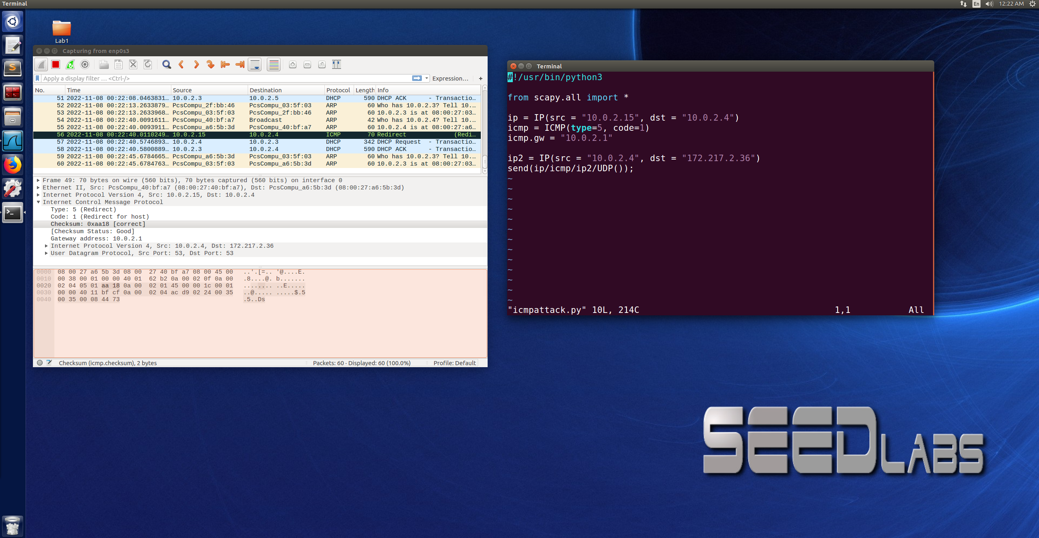

This screenshot shows that a successful redirect took place for the packet to go from A to B. I used the skeleton code provided in the textbook and filled in the missing pieces with the information from my vms.

**Questions:**

**1:**

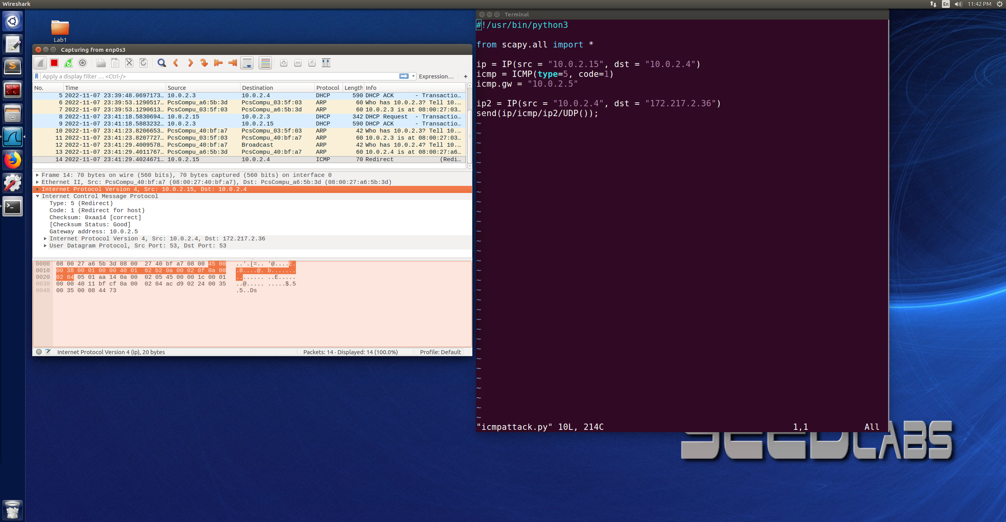

For this question we wanted to experiment and see if an ICMP redirect attack could be used on a remote machine. I used 10.0.2.5 which is one of my vms. As seen in the Wireshark screenshot above, a successful redirect did take place where the ICMP redirect attack was directed to a remote machine. This shows that you can use ICMP redirect attack to redirect to a remote machine because the packet was successfully redirected.

**2.**

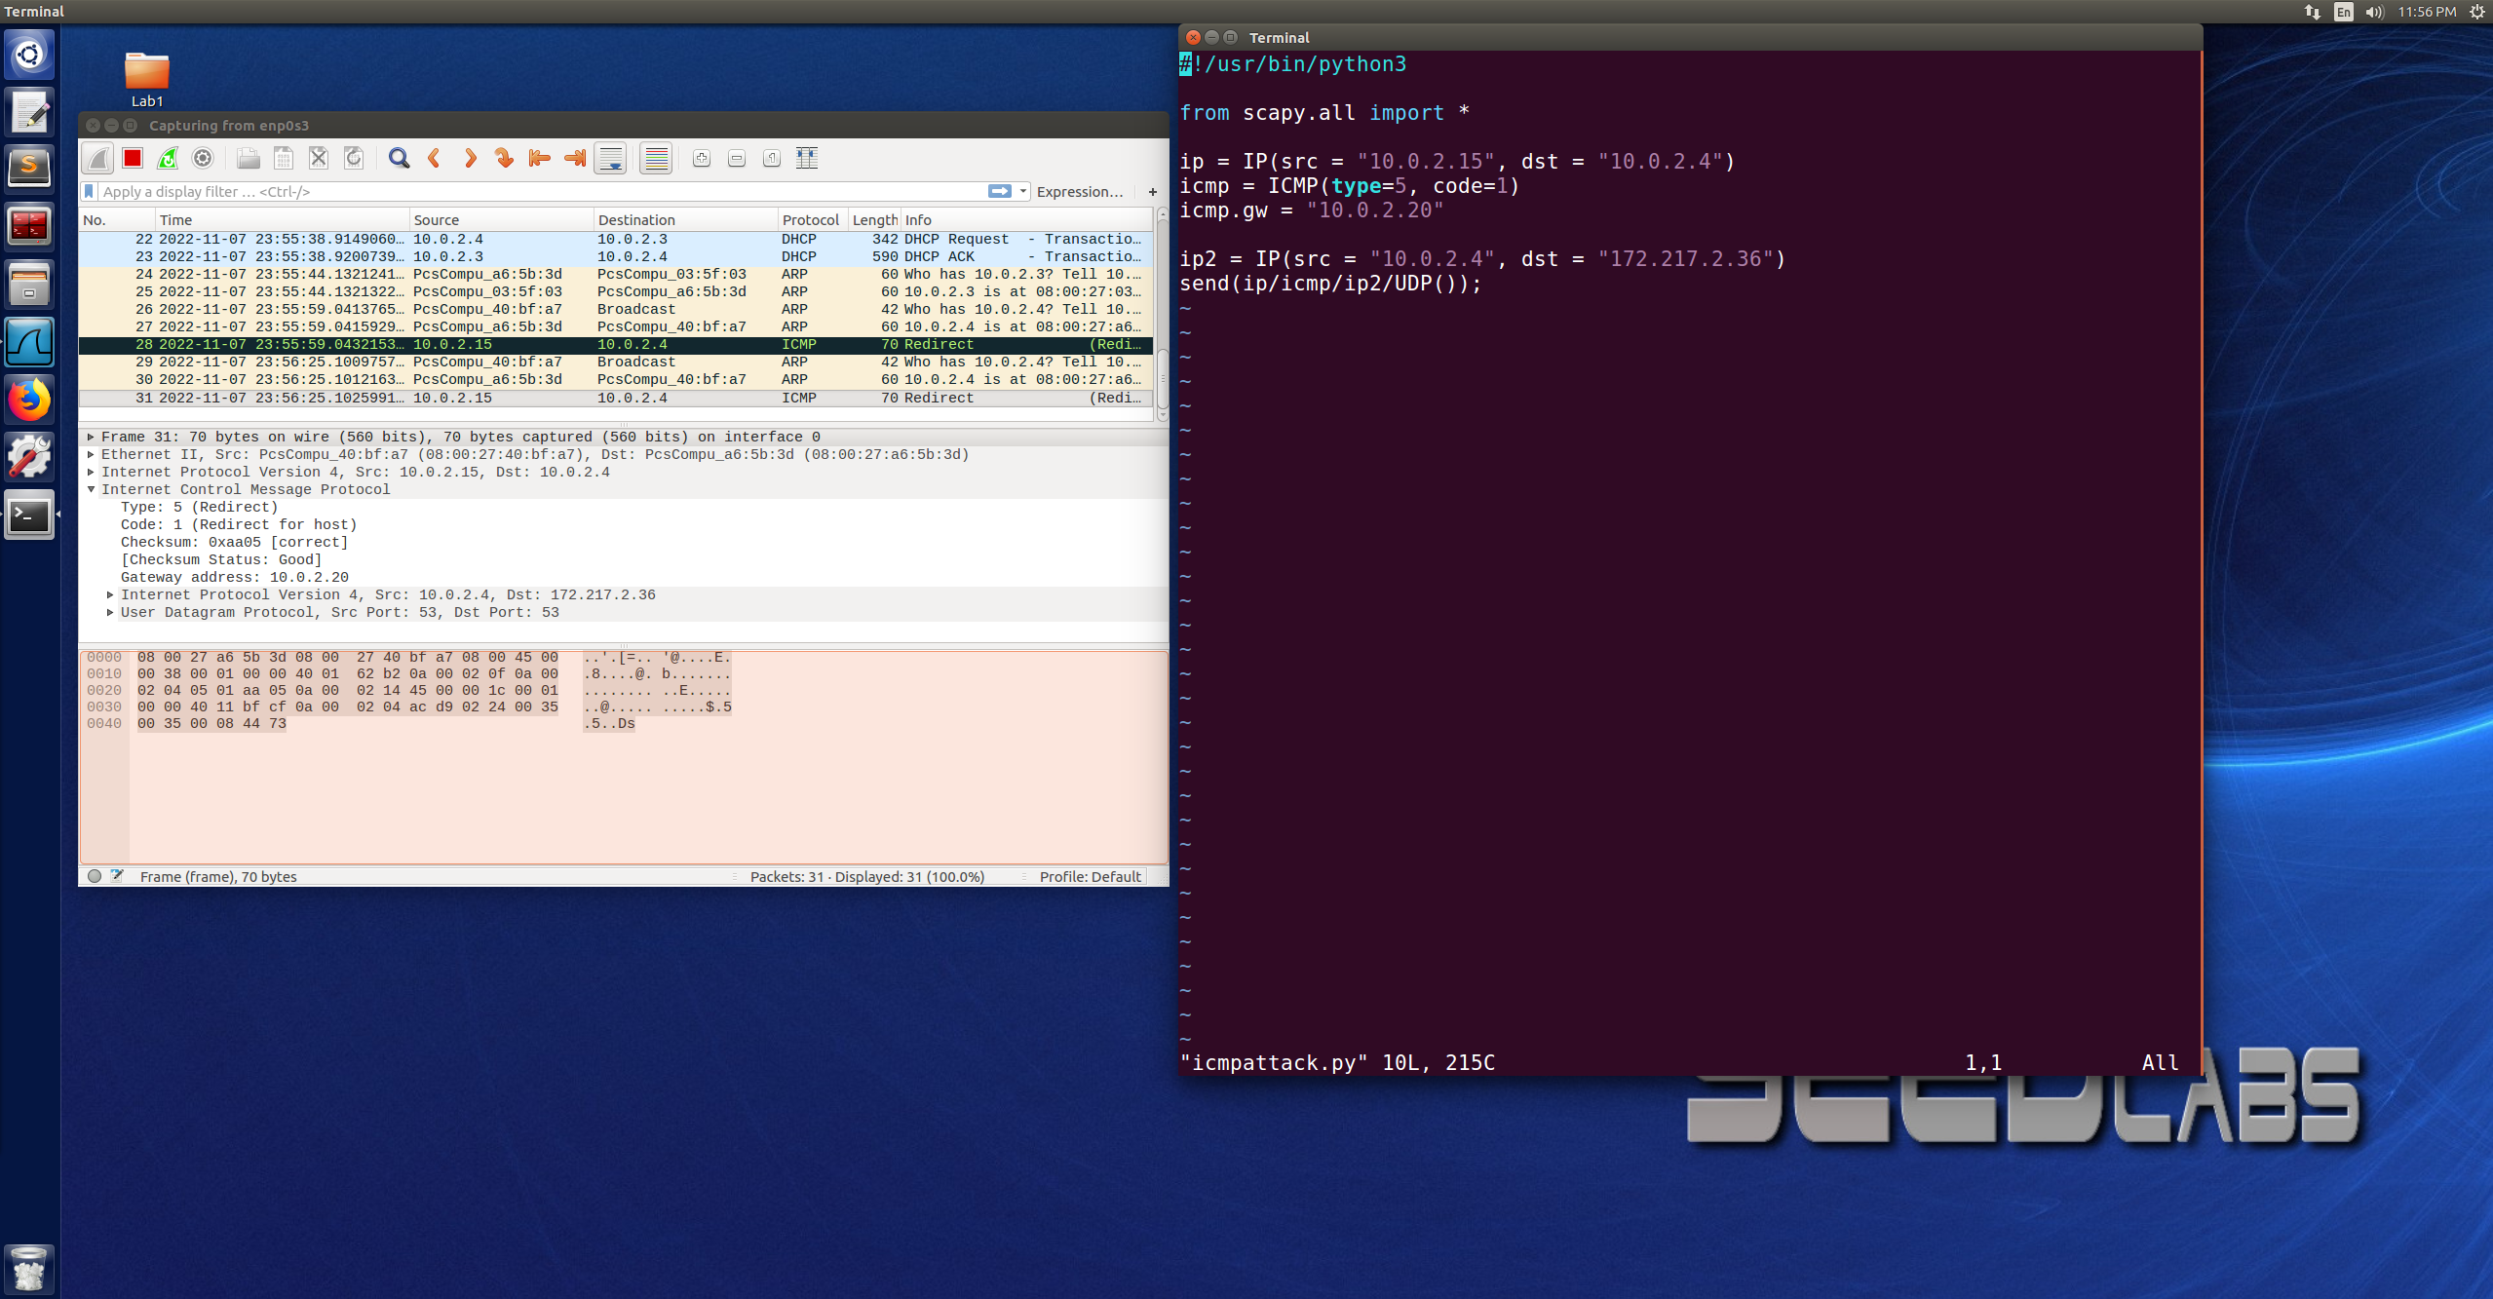

For this question we wanted to experiment and see if an ICMP redirect attack could be redirected to a non-existing machine that is either offline or non-existing. When the packet was redirected using a machine that didn’t exist, the ICMP packed was successfully redirected, but no other packets were received. This means that you would be able to carry out an ICMP redirect attack on a non-existing machine that is on the same network, but the packet will not be received by that machine.